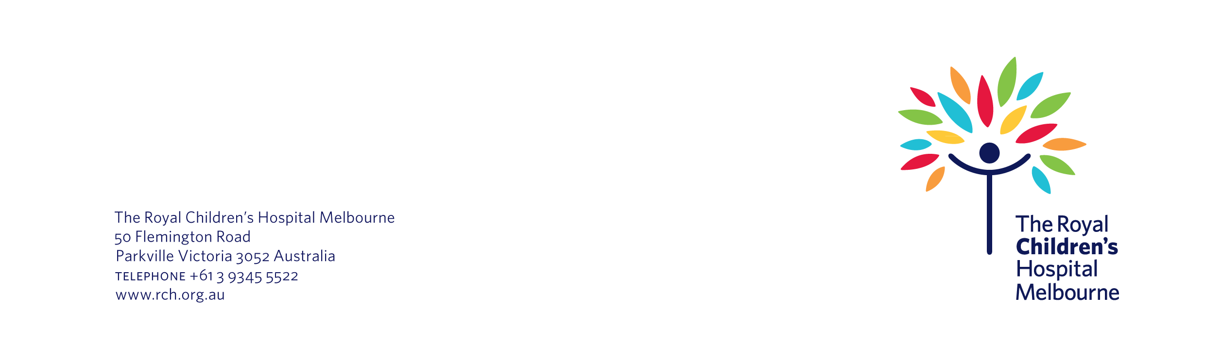
Name
Number Street Name
Suburb
State Postcode

Date

We are inviting your child to be in a research project at The Royal Children’s Hospital

Dear [Name],

We are inviting your child to take part in a new research project at The Royal Children’s Hospital. The project is about <insert plain language description>.

Why are we contacting you?

We are sending you this information because <you agreed to be contacted about new research project about <insert name>>. OR <Your child was recently treated in the <insert department name>. Your child has <insert condition> and may be suitable to take part>.

What is the research project about?

We are doing this research project because we want to <insert brief description of the aims of the project>.

We have enclosed an information statement and consent form about the project. This form explains the research project in more detail, including:

- what you and your child need to do in the research project
- the risks and benefits of participation
- happens to the information we would collect about you and your child
- how we keep you and your child’s information confidential.

What happens next?

Please contact us if you would like to take part in the research project or would like more information. You can call <insert name of researcher> on <insert phone number>. You can also email them on <insert email address>.

If we do not hear from you by <insert date>, we will contact you to check you received this letter.

Kind regards

Name
Department
The Royal Children’s Hospital

